**SIR APOLLO**

**END OF TERM III EXAMINATION 2023**

**PRIMARY ONE**

**LITERACY II**

**My name is ______________________________________________**

**I am in __________________________________________________**

**My school is _____________________________________________**

1. **Join and write.**

n __________________ y _________________

pi ck ___________________ The se _________________

t ___________________ n _________________

1. **Write words with these sound.**

oo _______________________ ee ________________________

_______________________ ________________________

_______________________ ________________________

1. **Read and draw.**
2. A man has a hat.
3. They are digging.
4. These are two chairs.
5. She is carrying a basket.
6. **Read the story and answer correctly.**

**My family.**

My name is Mary. There at home, father heads a family, my mother cooks food, my two brothers sweep the compound and three sisters wash the plates and clothes. We all do work every day. I love going to church on Sunday.

**Questions**

1. My name is _________________________________________________
2. __________________________ heads the family.
3. Who cooks food at home?

____________________________________________________________

1. How many brothers does Mary have?

_______________________________________________________________

1. The three sisters wash ____________________ and ________________
2. Who loves going to church on Sunday?

_______________________________________________________________

1. **Match correctly.**

lion no legs

duck four legs

bee two legs

snake six legs

1. **Name these pictures.**

|  |  |
| --- | --- |
| D:\Local Disk F\New folder\KIBUUKA 2023\pictures\DISAN PICS\pics\pen v.jpg | D:\Local Disk F\New folder\SECRETARY\NEW PICS\MY PHOTOS\PICTURES\LISA EVE\thumb pin.png |
|  |  |
| D:\Local Disk F\New folder\KIBUUKA 2023\pictures\kibuuka pic\hut.jpg | D:\Local Disk F\New folder\SECRETARY\NEW PICS\NEW PHOTOS\hat.jpg |
|  |  |

1. **Circle the correct words.**

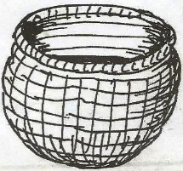

bakset bakest basket



rake kera reki

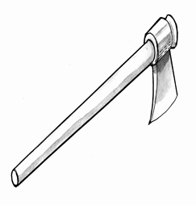

aex axe exa

1. **Match correctly.**

cow fillet

sheep beef

fish mutton

hen pork

1. **Write correctly.**

oby ____________________________ enh ____________________

shfi ____________________________ nus _____________________

llhi _____________________________ eey ____________________

oomn __________________________ refi _____________________

rgil _____________________________ ohe ____________________

1. **Copy correctly.**

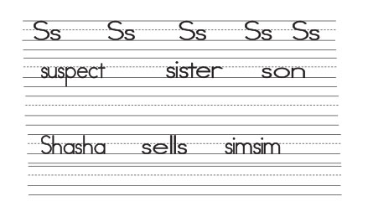

**END**